# Important! Don’ t forget to install the package listed below:
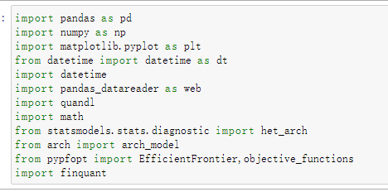
Step 1: Preselection
This step is aim to select stocks based on min predict swan beta, the predict method now include
- beta(the average of former swan)
- gamma(the avg+sd of former swan)
- K-means
There are two ways to preselect stocks, one way is automatically finished by program(only support gamma and beta at this time), the other is to preselect by yourself.
First Way:
Set all parameters in this block, the specific time refer to each swan please see adj Black Swan V Signature Model for reference.
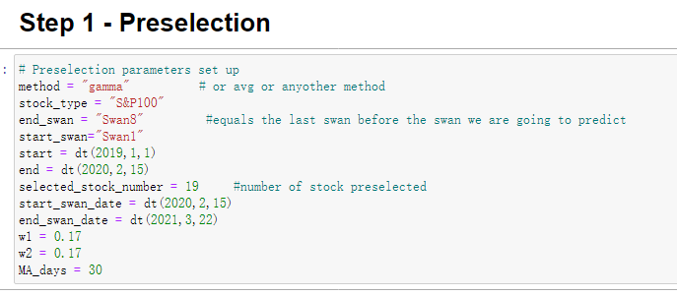
Ps:
1. the start and end are used to set Injection period which should be at least 1 year plus 60 trading days (at least 282 trading days)
2. The start_swan_date and end_swan_date are used to set the period for type E graph which is used to calculated PR rate.
3. Typically, you do not need to change MA_days, I left that parameters here for reference.

Second Way:
In the preselection step, if you want to finish preselection by yourself, use this block.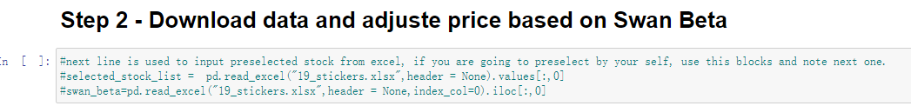

Please don’t forget to note the following block.
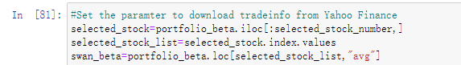
You will need to put stock selected and predict swan beta in 19_stickers.xlsx, you do not need to include title, just paste stock symbol and predict swan beta in it.

Input Data:
#all data listed below are based on old swan market performance, the beta is calculated with their correlation to drop of index(SPY and OEX)
- All_SwanBeta100 , All_SwanBeta500, MarketDD is included in document, just put them in the same folder as your New MVO notebook document
- You need to paste the corresponding optdata in optdata.xlsx (get optdata from google drive)

Step Two : Injection
#We use this step to adjust stock price based on their past swan performance, i.e. the stock price minus the market drop times the predict swan beta which is their predict performance during new swan.
In this step, typically you do not need to change any thing, just run the code. But if you want to try different market drop data, like the one include in the old MVO training material, just paste your data in trainingMarketdrop.xlsx and change this line to market_drop1 (just add 1 at the end)
Step Three : MVO
#This step is used to calculated required data from optimization process (predict return, predict sd…) Also, during this step, optdata which is the predict market performance given by yahoo finance analyst(download time listed on different documentation) is used to adjusted predict return.

Just run the program

Step Four : Optimization
#This step is based on mean variance optimizer and we max Sharpe Ratio at this step. Then we track our portfolio and market performance based on optimization result we get from out optimizer.

If you want to compare old and new sharpe ratio, paste the first two columns of WEDataBank (getting from old MVO) into old_weight.xlsx and use these two block
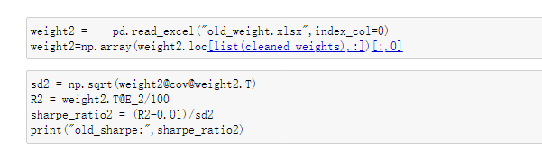
Out Put sheet:
- weight.csv include the stock selected and their weight.
- Injected_result.csv include the performance of market and our portfolio which could be used to draw type E graph.
- preselected_Stocks_info.csv include information need to do post allocation (PR,PR*SQRT(SR)…)
- WEDataBank.csv include other information that is calculated during MVO (just for reference)
- market_drop.csv include market drop info that could be used to run old MVO If needed.

